**­­­­CodeX Learner**

**Specification Document**

**Chander Thakur**

**Last updated: September 19, 2023.**

**Team name: Git Guardians**

Note* This Document is far from complete and iterations are being made, keeping in mind the team’s capabilities and the time limit.

**Project Overview**

This project is an ambitious e-learning project aimed at revolutionizing education and skill development in the digital age. This project leverages technology to provide accessible, engaging, and effective learning experiences for a wide range of learners, from students seeking academic excellence to professionals looking to enhance their skills and knowledge.

**Project Objectives**

The primary objectives of the project are as follows:

1. **Expand Access to Education**: To make high-quality educational content accessible to learners worldwide, transcending geographical barriers.
2. **Enhance Learning Outcomes**: To improve learner outcomes by offering interactive, engaging, and personalized learning experiences.
3. **Empower Skill Development**: To facilitate skill development and career advancement through specialized courses and resources.
4. **Foster Lifelong Learning**: To promote a culture of continuous learning by providing a diverse library of courses and resources.

**Target Audience**

1. **Students**: From primary school to higher education, offering a wide range of subjects and curricula.
2. **Professionals**: Seeking skill development, career advancement, and specialized knowledge.
3. **Lifelong Learners**: Individuals interested in personal enrichment and self-improvement.
4. **Instructors and Educators**: Providing tools and resources for educators to enhance their teaching methodologies.

**Requirement analysis**

**What is E-learning Platform and how it Works.**

An E-learning platform is a digital system or software application designed to facilitate the delivery of educational content and training materials to learners through the internet.

These platforms serve as virtual learning environments where instructors can create and deliver courses, and learners can access and interact with educational resources. Here's how an e-learning platform typically works:

Content Creation and Management: Instructors or content creators use the e-learning platform to develop and organize educational content. This content can include text, multimedia (videos, images), quizzes, assignments, and interactive elements.

1. User Registration and Enrolment: Learners register on the e-learning platform, creating accounts with their personal information. Learners can search for courses or programs of interest and enroll in them.
2. Course Delivery: Once enrolled, learners gain access to the courses they've chosen. They can view lectures, read course materials, and engage with multimedia content directly within the platform.
3. Progress Tracking: E-learning platforms track learners' progress throughout the course. Learners can view their own progress and achievements, helping them stay motivated.
4. Certification and Credentialing: Upon successful completion of a course or program, learners may receive certificates or digital badges to acknowledge their achievements.

E-learning platforms come in various forms, including Learning Management Systems (LMS), Massive Open Online Course (MOOC) platforms, and custom-built solutions. The choice of platform depends on the specific educational goals and needs of instructors, institutions, or organizations. Ultimately, e-learning platforms provide a flexible and efficient way to deliver education and training in a digital age, enabling learners to acquire new skills and knowledge conveniently and at their own pace.

**Why we required E-learning Project**

We want to build an e learning web app because it provides learner a way and follow a roadmap to go from beginner to advance in whatever they want to learn about. Many popular sites have great content for learners but while they explain something they might use words that have a whole different meaning and now we have to open another tab to look up what word means, and this goes on.

There are basic reasons for generating E –Learning Platform:

1. Accessibility: E-learning makes education and training accessible to a global audience.
2. Flexibility: E-learning offers flexibility in terms of when and where learning takes place. Learners can access content at their own pace and on their own schedule.
3. Cost-Effective: E-learning can be more cost-effective than traditional classroom-based education. It eliminates the need for physical classrooms, travel expenses, and printed materials. Organizations can also save on training costs by using e-learning for employee development.
4. Continuous Learning: In a rapidly changing world, continuous learning is crucial. E-learning allows individuals to update their skills and knowledge regularly to stay relevant in their fields.
5. Resource Efficiency: E-learning reduces the consumption of paper and other physical resources, contributing to environmental sustainability.
6. Standardization and Consistency: E-learning projects ensure that content is standardized and consistent across the board, ensuring that all learners receive the same quality of education or training.

This Project empower individuals and organizations to learn, adapt, and thrive in a rapidly evolving world

**What is the success metrics?**

A Success Matrix, also known as a Key Performance Indicator (KPI) matrix, is a valuable tool for evaluating the success of an e-learning initiative. It helps you define and track specific metrics and goals to measure the effectiveness and impact of your e-learning program.

Below, we have provided an example of a Success Matrix for an e-learning project, which you can customize to align with your project's objectives and goals.

E Learning Success Matrix:

|  |  |  |  |
| --- | --- | --- | --- |
| **Success Metric** | **Description** | **Target/Threshold** | **Data Source** |
| Learner Enrolment | Number of learners  Who have registered  For courses. | Target Number | LMS Analytics |
| Course Completion  Rate | Percentage of learners who complete the course | Target Number | LMS Analytics |
| Assessment Performance | Average score on course assessments. | Target Score | LMS Analytics |
| User Satisfaction | Learner feedback and satisfaction ratings. | Target Rating | Surveys/Feedback |
| Course Retention Rate | Percentage of learners who return for more courses. | Target Percentage | LMS Analytics |
| Skill/Knowledge Acquisition | Demonstrated improvement in learner skills/knowledge | Target Indicator | Pre/Post Tests |
| Course Content Quality | Evaluation of course content quality. | Target Rating | Peer Review |

Key:

Success Metric: The specific metric you're measuring.

Description: A brief description of what the metric represents.

Target/Threshold: The goal or target value for each metric.

Data Source: Where you'll gather data to assess each metric.

**Project Scope**

The project encompasses the following key components:

1. Content Development: Creation of high-quality e-learning modules, courses, videos, and other resources covering a wide array of subjects and skills.
2. Technology Infrastructure: Development and implementation of a cutting-edge learning management system (LMS) to host and manage content.
3. User Engagement: Implementation of interactive features, discussion forums, peer collaboration, and gamified elements to maximize learner engagement.
4. Assessment and Evaluation: Integration of assessment tools, quizzes, and performance tracking to monitor learner progress and ensure learning objectives are met.
5. Support and Resources: Provision of technical support, FAQs, and supplementary learning resources to assist learners on their journey.

**Functional Specifications**

This feature specification document serves as a comprehensive reference for the development team, stakeholders, and project managers to understand the scope and requirements of the e-learning platform's features. It should be regularly reviewed and updated as the project progresses and requirements evolve. 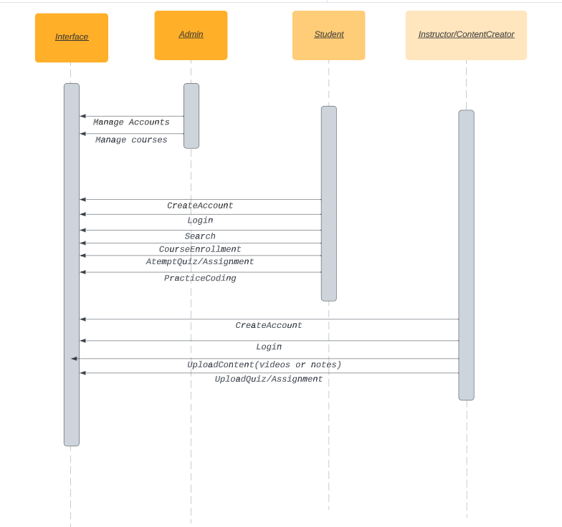

**User Registration and Authentication:**

1. User id
2. User Name
3. Priority: [High/Medium/Low]
4. Status: [Not Started/In Progress/Completed]

Description:

1. Allow users to register for the platform.
2. Implement secure authentication mechanisms.
3. Enable password reset and account recovery.

Cases :

1. A user creates a new account by providing personal information.
2. A registered user logs in using their username and password.
3. A user requests a password reset and successfully resets their password.

Dependencies :

1. Database for storing user information.

Acceptance Criteria:

1. Users can register, log in, and reset their passwords without errors.
2. Passwords are securely stored and encrypted.

**Course Creation and Management:**

1. User id
2. User Name
3. Priority: [High/Medium/Low]
4. Status: [Not Started/In Progress/Completed]

Description:

1. Instructors can create and manage courses.
2. Define course objectives, content, and assessments.
3. Set enrollment rules and access permissions.

Cases:

1. An instructor creates a new course, adding modules and lessons.
2. Instructors define quizzes and assignments within the course.
3. Instructors set course prerequisites and access restrictions.

Dependencies:

1. Database for storing course information.
2. User management system for assigning instructor roles.

Acceptance Criteria:

1. Instructors can create, edit, and delete courses.
2. Courses have defined objectives and content.

**Discussion Forums and Collaboration:**

1. User id
2. User Name
3. Priority: [High/Medium/Low]
4. Status: [Not Started/In Progress/Completed]

Description:

1. Provide discussion forums for course-related interactions.
2. Enable learners to collaborate on assignments and projects.
3. Support peer-to-peer and instructor-led discussions.

Cases:

1. Learners participate in course forums to ask questions and discuss topics.
2. Learners collaborate on group projects within the platform.
3. Instructors moderate discussions and provide feedback.

Dependencies:

1. User authentication and authorization.
2. Course creation and management features.

Acceptance criteria:

1. Learners can create and participate in discussions.
2. Instructors can moderate and manage discussion forums.

**Assessment and Grading:**

1. User id
2. User Name
3. Priority: [High/Medium/Low]
4. Status: [Not Started/In Progress/Completed]

Description:

1. Implement quizzes, assignments, and exams within courses.
2. Automate grading and provide instant feedback.
3. Allow instructors to review and override grades.

Cases:

1. Learners complete quizzes and receive immediate scores.
2. Instructors grade assignments and provide feedback.
3. Instructors can review and adjust final grades.

Dependencies:

1. Course creation and management features.
2. User authentication and authorization.

Acceptance criteria:

1. Quizzes and assignments are auto-graded accurately.
2. Instructors can manually grade and provide feedback.

**Security and Privacy in E-learning Platforms:**

Security and privacy are paramount considerations in e-learning, especially when dealing with sensitive educational and personal data. Ensuring the protection of data, maintaining learner privacy, and safeguarding against security breaches are critical for the success and trustworthiness of e-learning platforms. Here are some key security and privacy considerations in e-learning:

Security Consideration:

1. User Authentication and Authorization: Implement strong authentication methods, including multi-factor authentication (MFA), to verify user identities.
2. Data Encryption: Encrypt data in transit using secure protocols like HTTPS. Encrypt data at rest, such as user profiles and assessment results, to protect against unauthorized access.
3. Secure Coding Practices: Follow secure coding practices to prevent common vulnerabilities such as SQL injection and cross-site scripting (XSS).
4. Data Backups and Disaster Recovery: Implement regular data backup procedures and ensure data can be restored in the event of data loss or a security incident. Develop a disaster recovery plan to minimize downtime and data loss.
5. Security Monitoring and Incident Response: Employ intrusion detection systems (IDS) and intrusion prevention systems (IPS) to monitor for suspicious activity. Have an incident response plan in place to respond promptly to security incidents and breaches.
6. User Training and Awareness: Educate users about security best practices, including strong password management and recognizing phishing attempts.

Privacy Consideration:

1. Data Minimization: Collect only the necessary data from users, and avoid collecting excessive or irrelevant information. Clearly communicate to users what data is being collected and why.
2. User Consent: Obtain explicit consent from users before collecting and processing their personal data.
3. Privacy Policies and Terms of Service: Create clear and comprehensive privacy policies and terms of service documents. Inform users about how their data will be used, stored, and shared.
4. Data Access Control: Implement granular access controls to ensure that only authorized personnel can access and modify user data.
5. Data Retention and Deletion: Define data retention policies and automatically delete data that is no longer needed. Allow users to request the deletion of their accounts and associated data.

E-learning platforms must adopt a comprehensive approach to security and privacy by integrating these considerations into their development processes, policies, and procedures. By doing so, they can create a safer and more trustworthy learning environment for users.

**## Team Members**:

Sukhminder Singh 21BCS8221

Sakashi Thakur 21CBS1072

Shameen Ahmad 21BCS3807

Harsh Pandey 21BCS4517

Chander Thakur 21BCG1101

Rahul Ranjan 22BAI71369